Project Design Phase Solution Architecture

Project Name | Cosmetic Insights : Navigating Cosmetics Trends  and Consumer Insights with Tableau
Maximum Marks | 4 Marks

Solution Architecture:
Solution architecture is a complex process – with many sub-processes – that bridges the gap between business problems and technology solutions. Its goals are to:

- Find the best tech solution to solve existing business problems.
- Describe the structure, characteristics, behavior, and other aspects of the software to project stakeholders.
- Define features, development phases, and solution requirements.
- Provide specifications according to which the solution is defined, managed, and delivered.

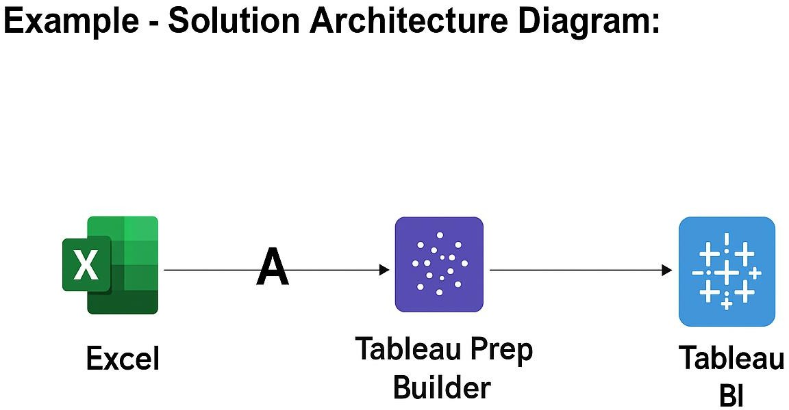

2).

